Get Started

What is Excel?
With Excel on your PC, Mac, or mobile device, you can:
- Streamline data entry with AutoFill.
- Spot trends and patterns with data bars, spark lines, color coding, and icons.
- Get chart and PivotTable recommendations based on your data, and create them with one click.
- Share your work from within Excel, using OneDrive.
- Edit spreadsheets with others, wherever they are

Create a workbook
A workbook is a file that contains one or more worksheets, to help you organize your data. You can create a workbook from a blank workbook or a template.
Create a workbook
- Open Word.
- Select Blank workbook.
Or, press Ctrl + N.
- Start typing.
Create a workbook from a template
- Select File > New.
- Double-click a template.
- Click and start typing.
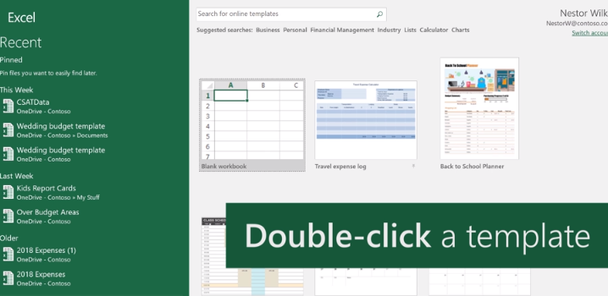

Insert or delete a worksheet
In Excel, you can easily add, rename, and delete worksheets in your workbook.
Insert a worksheet
- Select the plus icon.
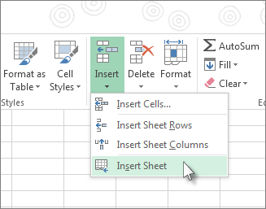
Or, select Home > Insert > Insert Sheet.

Rename a worksheet
- Right-click the sheet, select Rename, and type a new name.
Or, double-click the sheet name on the Sheet tab to quickly rename it.
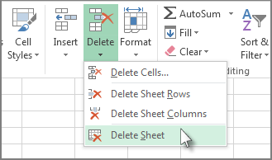
Delete a worksheet
- Right-click the sheet and select Delete.
Or, select the sheet, and then select Home > Delete > Delete Sheet.

Move or copy worksheets
You can move or copy a worksheet in the same workbook to organize your workbook exactly how you want.
Move a worksheet within a workbook
- Select the worksheet tab, and drag it to where you want it.
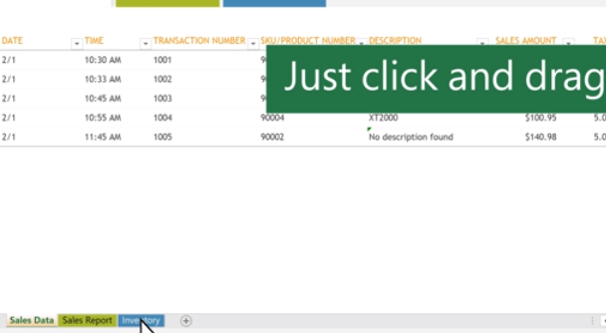
Note: Be aware that calculations or charts that are based on worksheet data might become inaccurate if you move the worksheet.
Copy a worksheet in the same workbook
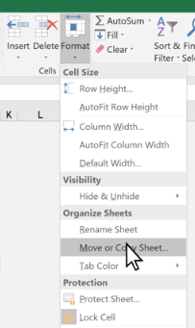
- Press CTRL and drag the worksheet tab to the tab location you want, or right-click the worksheet tab and select Move or Copy.

- Select the Create a copy checkbox.
- Under Before sheet, select where you want to place the copy.
- Select OK.
